ULTIMATE FACE RECOGNITION

Author: Bedirhan SAYAR
Yeditepe University Electrical Electronics Engineering Department
Email:Bdr1905@mynet.com

Note: The phone number seen at the images is not REAL

Starting UFR

First you have to start the matlab program and select the main directory.

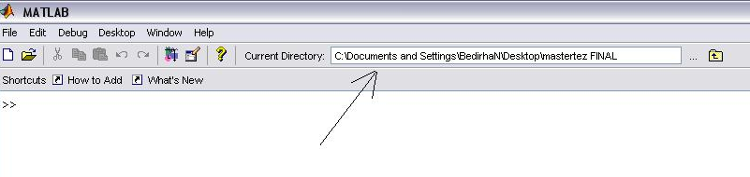

After this selection, type ‘START’ to open the program. Then a bar that contains a redline which moves on it can be seen.

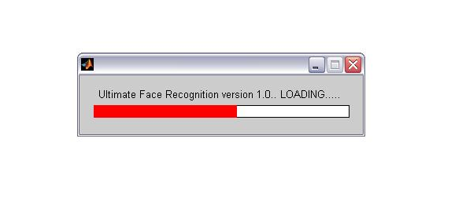

Then the main menu of the program can be seen.

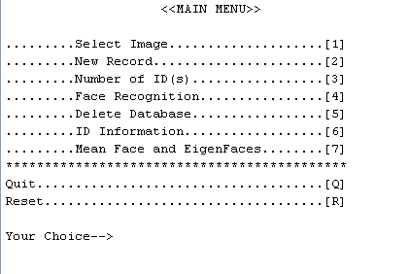
4.1.2 Selecting Image

By pressing ‘1’ a window appears then you can select an image. The supported format of the image is jpeg.

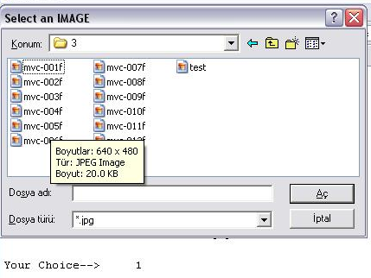

After the image selection the selected image will be shown to you.

Figure 4.5 Selected image

The software makes some operations to the images. Face recognition can be made if all of the images have the same size and all of them are grayscale. Images are represented by matrices and for matrix operations all of them must be a square matrix with the same size. First the image is converted to grayscale by eliminating the hue (color) and saturation information while retaining the luminance. After this, the size of the image will be changed by down sampling. The arranged size of the software is 250 by 250. For example if you select a color image has a dimension of 1024 by 768, it will be a grayscale 250 by 250 image.

New Record

First you have to select an image. Then type “2” if you want to save this image to the database. The software will give automatically an ID number to your face. If the database is empty, the first face will have an ID number 1. If you add a second image then its ID number will be 2 and so on. After this the software wants you to enter the information about the person. This information is stored to other databases. One of these databases is called IDnumber.DAT. For our example it is “1.DAT”. The name of the second database is same as the name of the person. Here it is “Bedirhan.DAT”. Contents of these two databases are same. The first one is used by the software automatically for giving the information about the matched person when the face recognition is made. For example if the person’s ID is 3 then it opens “3.DAT” and shows the recorded information to the user. The second one will be explained in ID information part.

First enter the name, surname and the phone number of the person. After this UFR asks if the person is allowed or not for access. The corresponding led will turn on according to typing “y” or “n”. It will be explained in hardware section.

Last a reference image must be selected for full information of the person. The reference image will be shown when the recognition is done. Selecting a reference image is recommended because you may not remember all of the names. Thus you can easily understand if this is the correct person or not. If you don’t want to add reference then push “cancel” button. The other data will be saved.

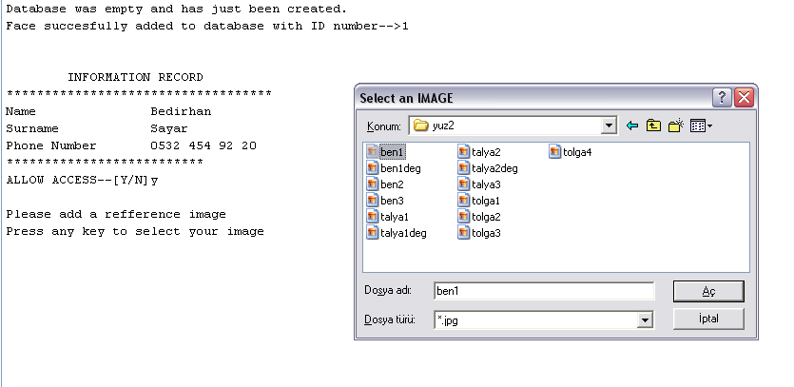

ID Information

By selecting 3 you can see how many IDs are recorded to the database.

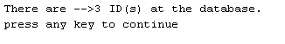

If it is empty than you will see “database is empty” message

Face Recognition

First of all you have to select an image that you want to compare with the saved images. Then type “4” for the face recognition. The software checks the database, tells the ID number of the face (if the face is recorded before), turns on the corresponding leds according to the answer of allow access then displays the information of this person.

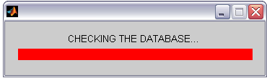

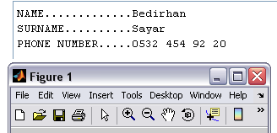

If the new face does not exist at the database then, the software warns you about it but shows the similar person stored in the database.

Deleting the Databases
Type “5” at the main menu then the program asks you to delete databases or not. If you type “y” the database will be deleted.

ID Information

The ID information menu appears if you type “6” at the main menu.

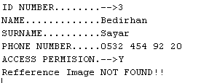

If you want to display the information about the person, then type”1”. The software asks you the name or ID number of the person. Typing the name or ID number is case sensitive. The computer will show the information if exists inside the database.

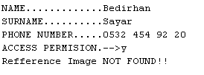

The picture of the person will shown if you add a reference image to this person when adding him/her to the database.

Mean Face and Eigenfaces

Typing “7” at the main menu will show the eigenfaces and the average of faces recorded. There must be at least 2 faces inside the database. Here you can see the eigenfaces .

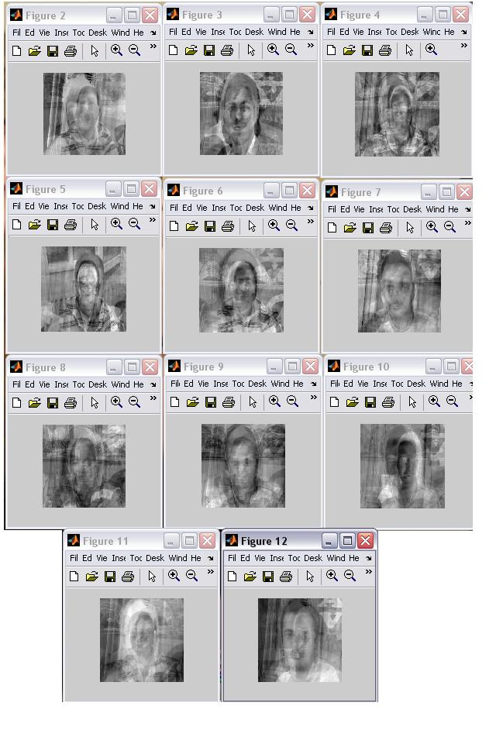

The corresponding average is shown like,

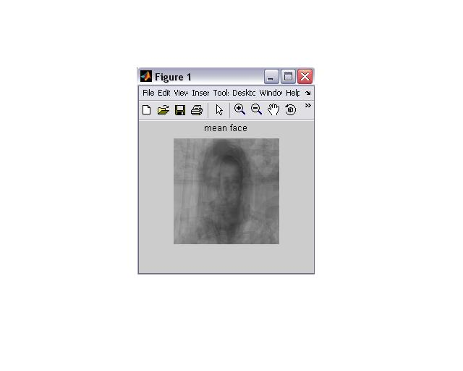

Possible Errors

The UFR is designed with feedbacks and corrections for all of the menus included in the system. Thus, if the user pushes a wrong key, the software warns him/her, and so that a correct selection can be done. This means the software never ends or crashes unless the user wants. If you want to end the software type “q” or “Q” from the main menu. Also you can reset the software with typing “r” or “R”. This operation closes all the pictures opened and deletes the variables stored in the memory.

